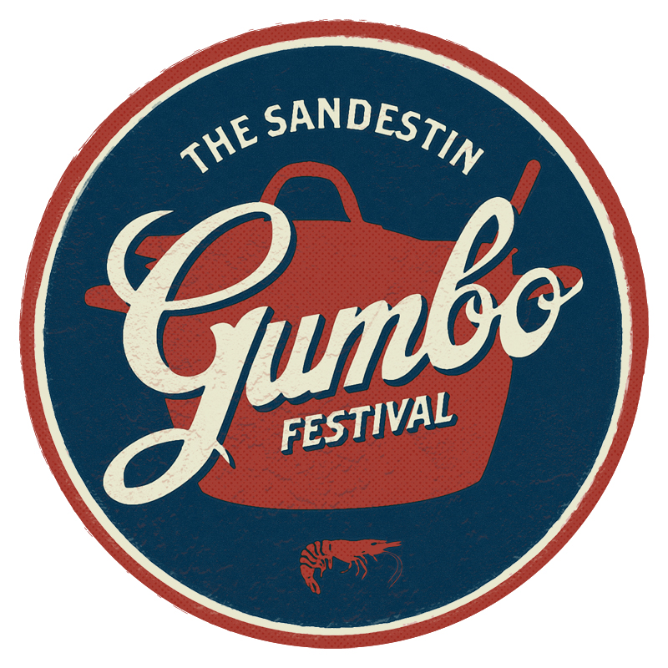

Dear Business Owners and Restaurants:

Preparations for the 35th Annual Sandestin Gumbo Festival are underway. The Gumbo Cook-off will take place February 24th from 12-4pm. In addition to Saturday’s Gumbo Cook-off, we’ll be featuring a variety of other events throughout the weekend.
- Now, we invite you to join in the fun! By becoming a participant in the 35th Annual Sandestin Gumbo Festival, your business will receive free advertising and publicity, worth thousands of dollars, January through February including:
  - Your business’s name listed in print and radio ads, flyers, posters and press releases.
  - An exclusive feature in the Taster’s Guide, which will be distributed to each event guest and will include a brief description and highlight noted by each participant.
  - Entered to win $1,000 worth of free advertising from our radio sponsor to be used over the next year.
  - Free advertising from our radio sponsor. Possible live tastings of gumbo dishes and bloody Mary’s on air prior to the event.

2024
- We are excited to also be giving each participant 2 tickets to The Sandestin Wine Festival’s Friday Grand Tasting on April 12th, 2024!
- Back this year is the Best Bloody Mary’s at The Beach component! Vodka will be sponsored and you provide all the fixings! Compete with some of the finest bars and restaurants on the Panhandle! You will be entered to win the “2024 Best Bloody Mary at The Beach” and the people will vote their favorite!
- Feel free to participate in one or both competitions.
- Each Gumbo participant will get a $500 stipend to go towards making their gumbo.

This competition is open to both restaurant and non-restaurant participants. Categories will be broken down as follows:

Participated 1-5 years: Participated 5+ years: People’s Choice Best Display:
1st Place 1st Place 1st Place 1st Place
2nd Place 2nd Place 2nd Place
3rd Place 3rd Place 3rd Place
4th Place 4th Place
Honorable Mention Honorable Mention

Non-Restaurant 2024 Best Bloody Mary at The Beach
1st place 1st Place
2nd Place 2nd Place
3rd Place

Judging will be made by a panel of select food critics and local celebrities. Each participant’s identity is concealed to ensure judging is strictly based on the quality of Gumbo presented. The awards ceremony will be held at approximately 4:15 pm and will recognize all participants as well as the winners.

We are proud to announce the Sandestin Gumbo Festival will be partnering with Sandestin Foundation for Kids and The Fisher House of The Emerald Coast this year. Proceeds earned will go to benefit these charities. The Sandestin Foundation for Kids and The Fisher House of The Emerald Coast are a critical part of this event as their teams assist in the coordination of our volunteers who help in every facet of the day’s needs.

Please plan to attend a meeting with all participants and organizers to discuss event details, booth locations and distribute compensation tickets and parking vouchers. The Participant meeting will be held on Tuesday, February 6th at 3:00 PM in The Village of Baytowne Wharf.

Enclosed is an information sheet that should answer most of your questions, plus a commitment and information form for the taster’s guide.

For your business to be included within ALL the advertising collateral, we ask that commitment forms be sent in to us by Wednesday, January 31, 2024. It is imperative that we receive your information by this deadline to ensure maximum marketing exposure for this great community event! Late entries will be accepted; however, we cannot guarantee full advertising opportunity. NOTE: Booth locations will be chosen in the order in which your commitment forms and checks were received.

Please mail or email Commitment Forms to:

Baytowne Wharf Neighborhood Association
Attention: Kensley Brooks
147 Tupelo Courtyard
Miramar Beach, FL 32550

Contact: Kensley Brooks
E-mail: kensley@baytownewharf.com

If you have any questions, please feel free to contact Kensley Brooks at 850-267-8110 or kensley@baytownewharf.com. We certainly appreciate everyone’s continued involvement and support of this event. Thank you and we look forward to hearing from you soon.

2024 PARTICIPANT Q&A

- How much Gumbo or Bloody Mary mix/fixings should I prepare? We are planning to accommodate 2,000 attendees for the 2024 event. For Gumbo Participants - Please base the amount of gumbo you bring on at least that number of people plus tastings for at least 2 rounds of judging. (We suggest 50 gallons.)
Participants will have an opportunity to sell Gumbo and Bloody Mary’s from 4pm – 5pm after the event. This will be in addition to the quantities requested for the event. All transactions are your responsibility.

- What supplies will be provided for you?
The Village of Baytowne Wharf will provide spoons, napkins, and sample sized bowls (4 oz.) for the gumbo, and sample sized cups (6 oz.) and vodka for the bloody Mary’s, tables, linen, restaurant signs, trashcans, power source, parking, and security. Use of propane is discouraged, but allowable in the right location with propane placed outside of footprint of tent.

- What must participants provide?
Each participant is required to:
- Reserve their table with an application
- GUMBO PARTICIPANTS: Provide gumbo. You will also need a fire extinguisher, chafing dishes, sternos, extension cords, serving utensils, and staff to serve and operate your booth.
- BLOODY MARY PARTICIPANTS: Provide bloody mary mix + fixings and a staff to serve and operate your booth.

- What type of promotion will be used for the event?
Participants will receive advertising in our local area through radio, billboard, magazine, and newspaper ads, as well as a full publicity campaign. Participants may also be eligible for live on-air tastings the week prior to the event.

- Can we bring promotional material to the event?
Yes, bring balloons, koozies, T-shirts, menus, etc. to give away at the tasting. This is a terrific opportunity for your business staff to meet potential customers and thank current ones!

- What are the criteria to be included in the Championship?
For Gumbo Participants: Your Gumbo MUST BE homemade. You CANNOT out-source the preparation of your gumbo to another restaurant/business; doing so will be grounds for disqualification. Please note there are a variety of gumbos. It does not necessarily have to be seafood gumbo. All gumbo must be prepared prior to arrival. Reheating of gumbo is the only day of food preparation allowed. Any other food preparation could possibly disqualify you from award consideration.

If you have any questions about the criteria, please contact us for verification.

- What happens if I run out of gumbo?
If you run out of gumbo prior to the end of the event it will affect your total score that has been determined by the judges. It is imperative that you make enough gumbo to last from 12 pm – 4 pm to ensure that the “People’s Choice” is chosen fairly. There will be a 3.5 point deduction for every half hour prior to the end of the event if you run out of gumbo.

- How do we qualify for the “Best Display” award?
We will provide a 10X10 tent for your booth space. Choose an interesting idea for your booth and decorate and dress up in the “Mardi Gras” spirit. In order to keep up the appearance of the Village, you are not allowed to use nails, screws, staple guns, tape, etc to mount anything on the actual building structure or tent. Doing so will disqualify your restaurant for this award.

- What time can we arrive to set-up for the event?
You may arrive at 8AM the day of the event; NO set-up will be permitted prior to this time. A load-in schedule will be established at the Participant’s Meeting.

- What time should we be ready to serve Gumbo and Bloody Mary’s?
At the participant meeting, we will give you your designated tasting time. It is your responsibility to have your gumbo ready 30 minutes prior to the tasting time.

- Where do we unload our supplies and park?
All participants will be permitted to unload their vehicle in front of their booth. Absolutely no unloading AFTER 10AM

- Parking
Your business will be permitted to park two (2) vehicles in Marina parking lot. Parking passes will be given out at the Participants Meeting.

2024 PARTICIPANT COMMITMENT FORM
(PLEASE MAIL OR E-MAIL THIS FORM AND RETURN BY WEDNESDAY January 31, 2024 TO MAXIMIZE YOUR AD OPPORTUNITIES.)

Participant Name:
Contact Name:
What will you be serving: |  | Gumbo Bloody Mary Both
Will you need power: |  | Yes No
Mailing Address:
(If different from Business Address)
Primary Contact Phone No.:
Business Phone/Other Phone:
Fax Number:
E-mail Address:
Best Time to Contact: |  | Morning | Afternoon |  | Evening
Brief Description of Business:
(to be included on Taster’s Guide)
2-3 full sentences
Special Requests:
Please mail or e-mail this for to: |  | Baytowne Wharf Neighborhood Association
 |  | ATTN: Kensley Brooks
 |  | 147 Tupelo Courtyard
 |  | Miramar Beach, Florida 32550
For questions, please contact Kensley Brooks, Village of Baytowne Wharf Events Manager, at
kensley@baytownewharf.com

